HOW TO JOIN SYSTEM TO DOMAIN (WINDOWS 7 & WINDOWS 10)

STEPS TO JOIN A COMPUTER TO A DOMAIN
- Know the domain name and ip e.g (test.dns, 10.10.11.11)
- Have access to the domain Administrator account e.g (Administrator, password)
- Set the DNS on the computer manually to point to Domain Server DNS if your router has not been configure to do so.
- On the Start screen, type Control Panel, and then press ENTER.
- Navigate to System and Security, and then click System.
- Under Computer name, domain, and workgroup settings, click Change settings.
- On the Computer Name tab, click Change.
- On the Computer Name, change the computer name to a unique name (to make identification easy) e.g MD-SEC-PC
- Under Member of, click Domain, type the name of the domain that you wish this computer to join, and then click OK.
- Click OK, and then restart the computer.
- Login to your system with the domain account.
Windows 7
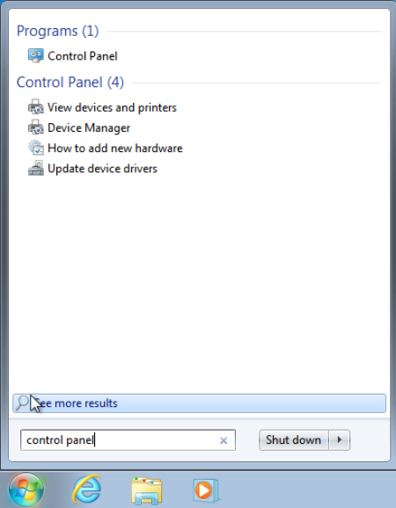
Step 4 Step 5

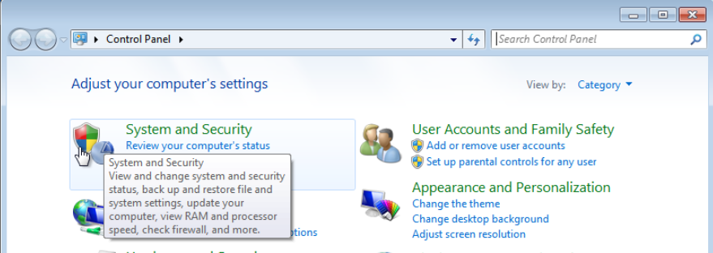

Step 5 Step 6
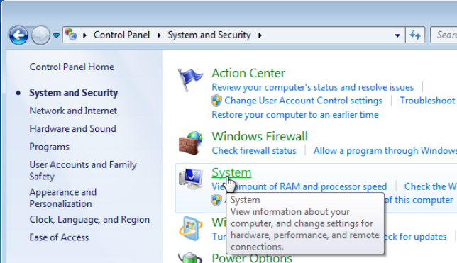
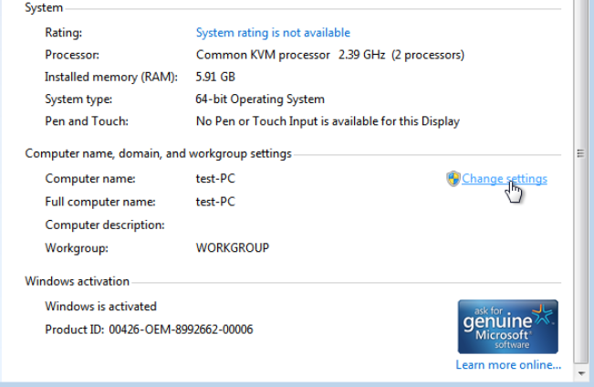

Step 7 (win7) Step 7 (win10)
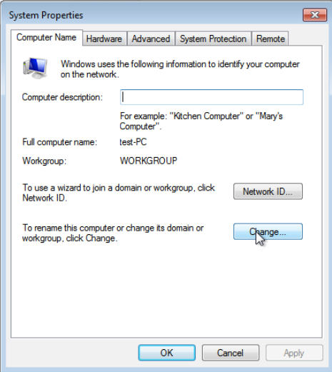
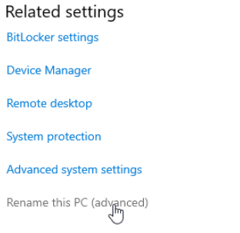

Step 8 & 9 Step 8 & 9
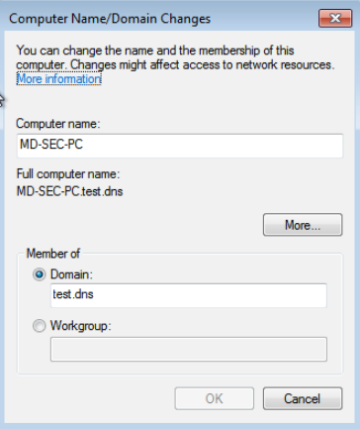
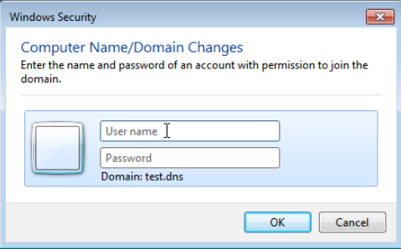

Step 8 & 9 Step 10
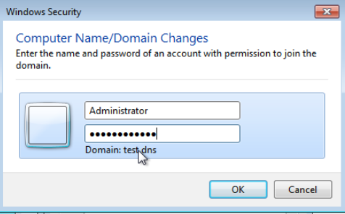
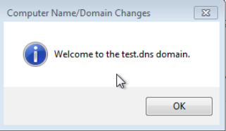

Step 11 Step 11
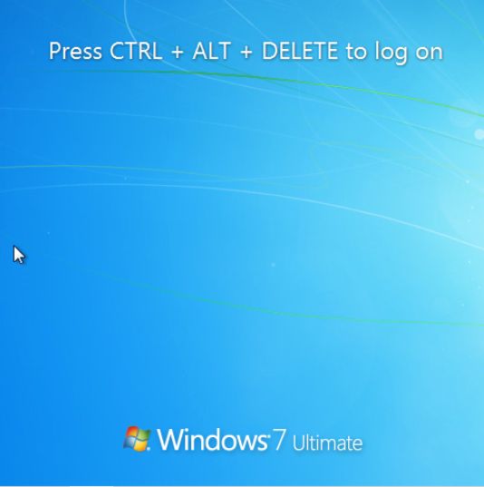
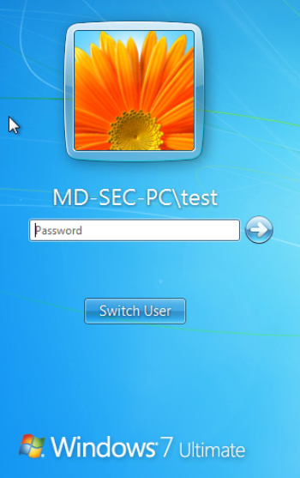

Step 11

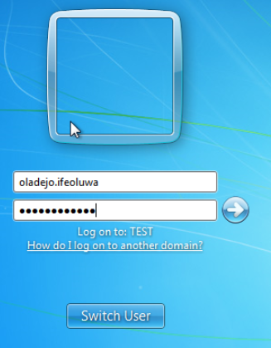

Step 3
